Dear Writer,

I hope you will find the bellow information useful and be able to provide me with the professional high quality work, as I do not have time to do it myself due to my work commitments. Thank you in advance.

Please read this properly, as well as the attached guidelines handbook in separate document.

Area - Fashion management (although the topic is more about fashion marketing management I believe)

Needed latest by 6th of May Saturday as I must check it and put it together also write reflective statement and print – my final submission deadline is 9th of May.

Title is not established yet (would be great if you would come up with one in the end, if no I will make up one, once dissertation is written)

The dissertation needed for my submission must be about “see now, buy now” model in fashion. This model is applied when fashion brand shows their fashion show and customers can purchase collection immediately after the show. Some brands only offer limited selection for “see now, buy now” – like for example only certain type of bags are available to purchase immediately, but not all collection.

Research and all dissertation must be focused on luxury fashion sector (if it is too limited may be classified as premium sector and focus on premium as well as luxury brands) and focused from brand perspective – not from consumers (how it affects brands operations etc…)

The aim for the research is to discuss if the “see now, buy now” model is only a marketing trick to (perhaps) enhance sales and create a buzz or is it a new business model, which will eventually be a new way how fashion shows work. (This is the general idea for the aim, however it must be written properly)

- Explore the role of the catwalk.
- How does it affect business operations?
- How does it affect sales?
- Stock? Are items sold out quickly after shows? Which items?
- Is it a good way of testing which products sell out and which no – so companies can produce better collection later and increase turnover? (all answers can be found in secondary research and faked in interviews for desired results..)
- How does it affect elite customers who could get collection before anyone else?
- Does it make luxury too accessible and less desirable?
- Does it create space for limited exclusive collections?
- Or bespoke services could become more popular for elite clients?
- Is it a long term or is it just marketing idea?
- Is it good because high street brands do not have time to copy collections?
- Does it work like impulse buying and makes customers buy more?
- What about returns? Maybe it increases returns (answers from interviews)

Please cover as many as you can and which are relevant. All these questions are perfect for advantages and disadvantages.
Please mention limitations.

Objectives: (also must be rewritten properly)

- To identify what it is and theories around it.
- Advantages of see now buy now for the brand.
- Disadvantages.
- Future of see now buy now.

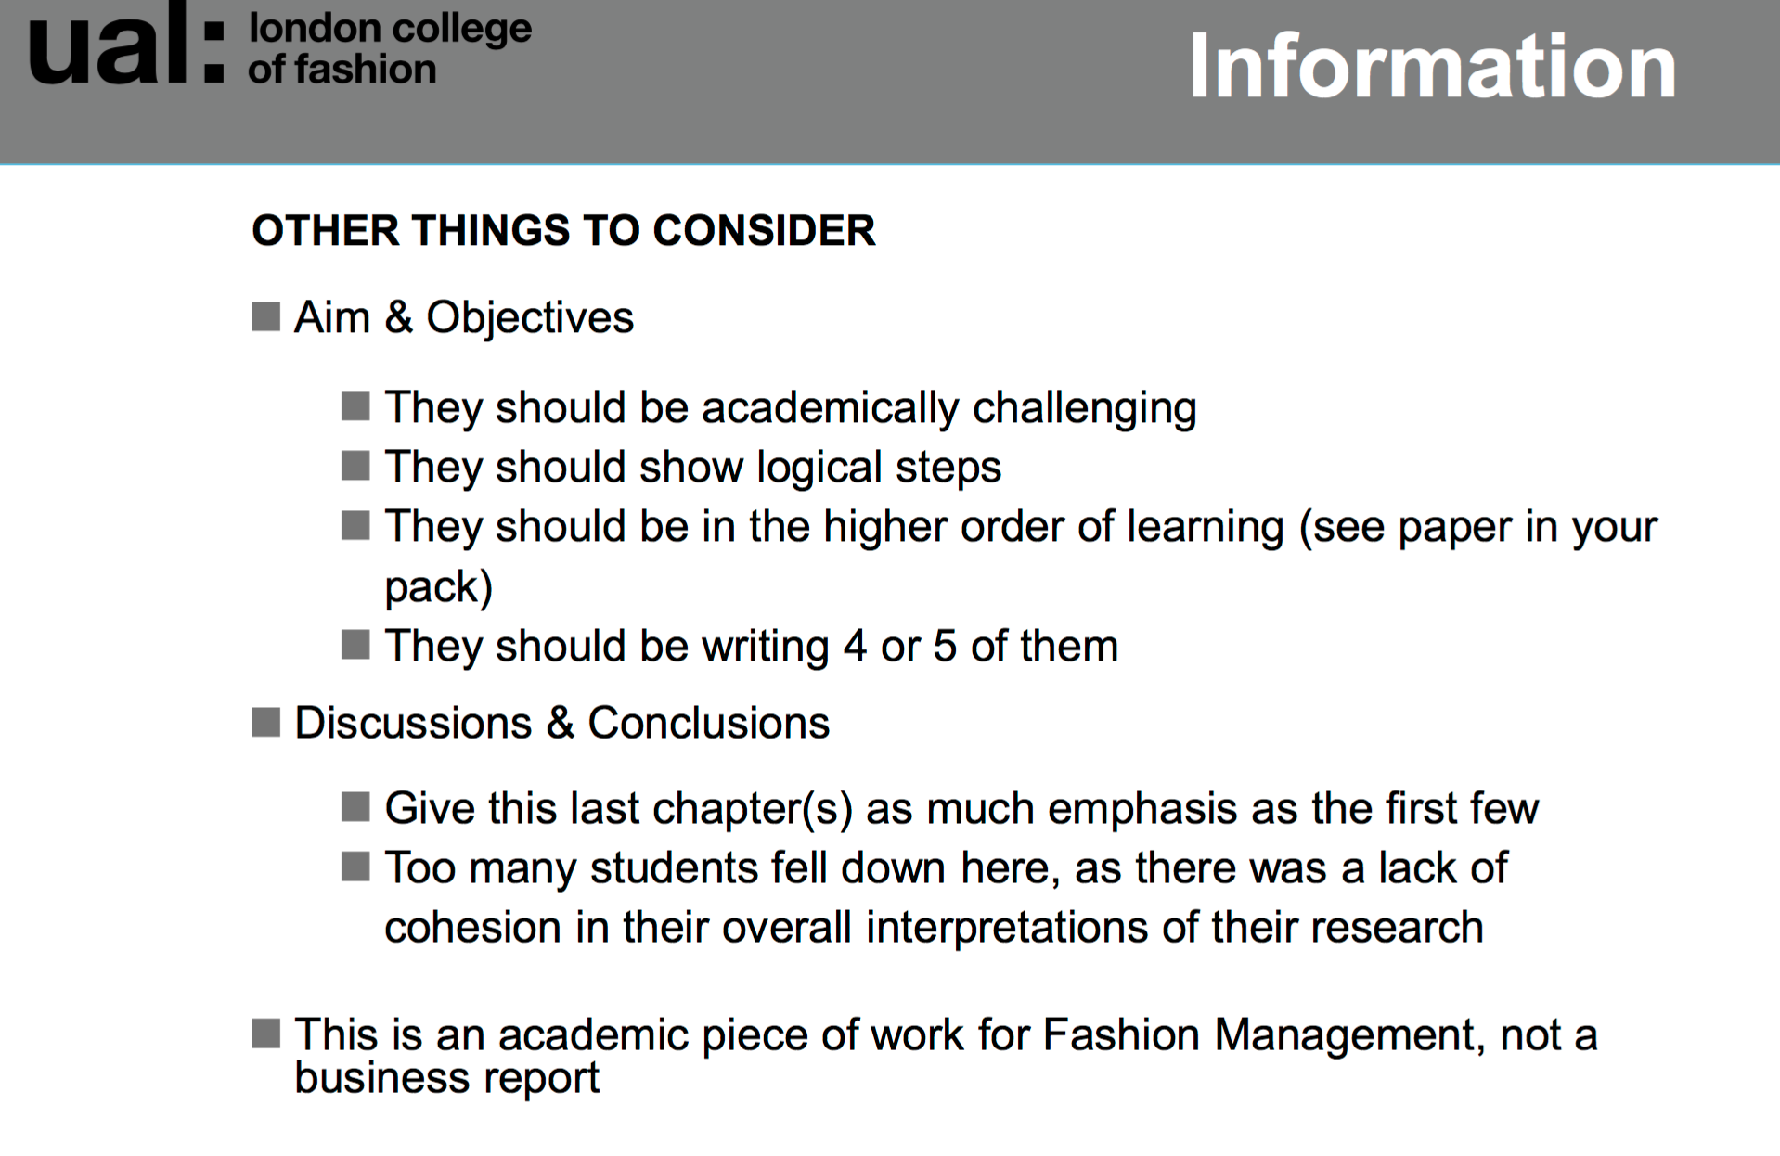
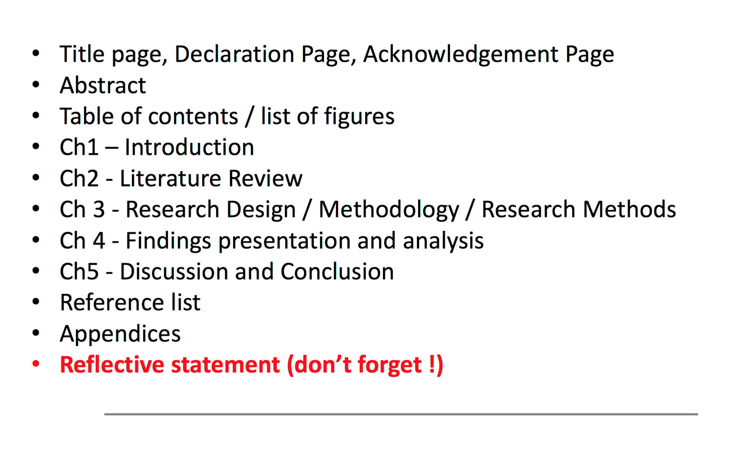
Reflective statement I will of course write myself .

Literature review:

Please use appropriate theories. Especially have a look and include Kapferer, Bastian and Fill as they were suggested by my supervisor. In the picture bellow, there are some key books, which you can find in my e-library. There are log in instructions provided bellow as well.

Some suggestions for theories: Trickle down, instant gratification, hierarchies of shows, impulse buying,

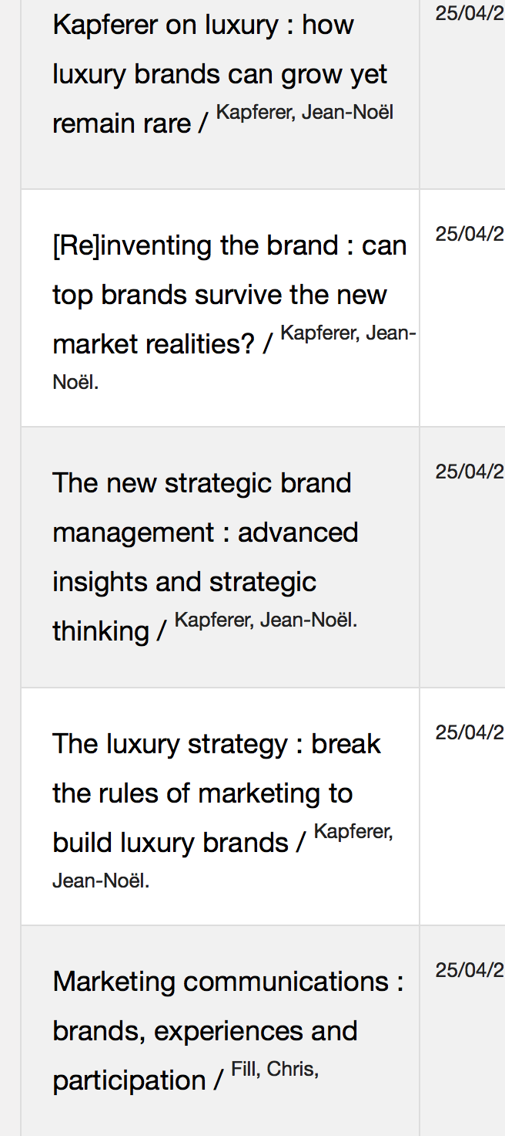

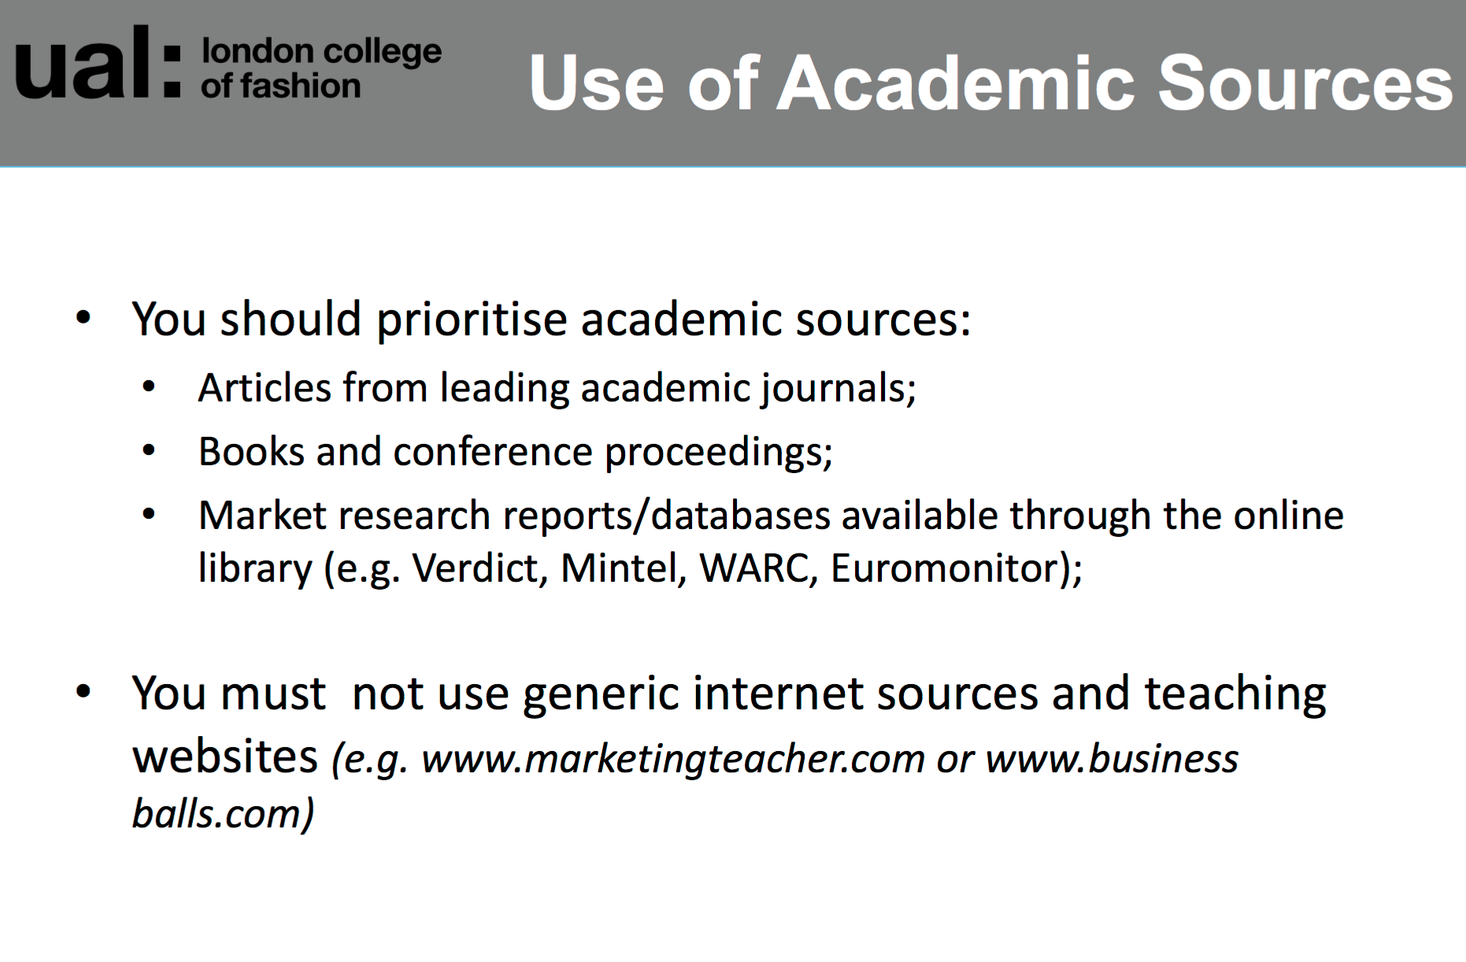

Log in: CER13405726
Password: A+Dissertation

Link to library:

https://libsearch.arts.ac.uk

Link to Databases:

http://arts.ac.libguides.com/az.php?a=m

E-journals :

http://bt2ha9xt3y.search.serialssolutions.com

Most of e-books could be found on dawsonera:

https://www.dawsonera.com

You have to press the corner with sign in then this window pops up and press Shibboleth login
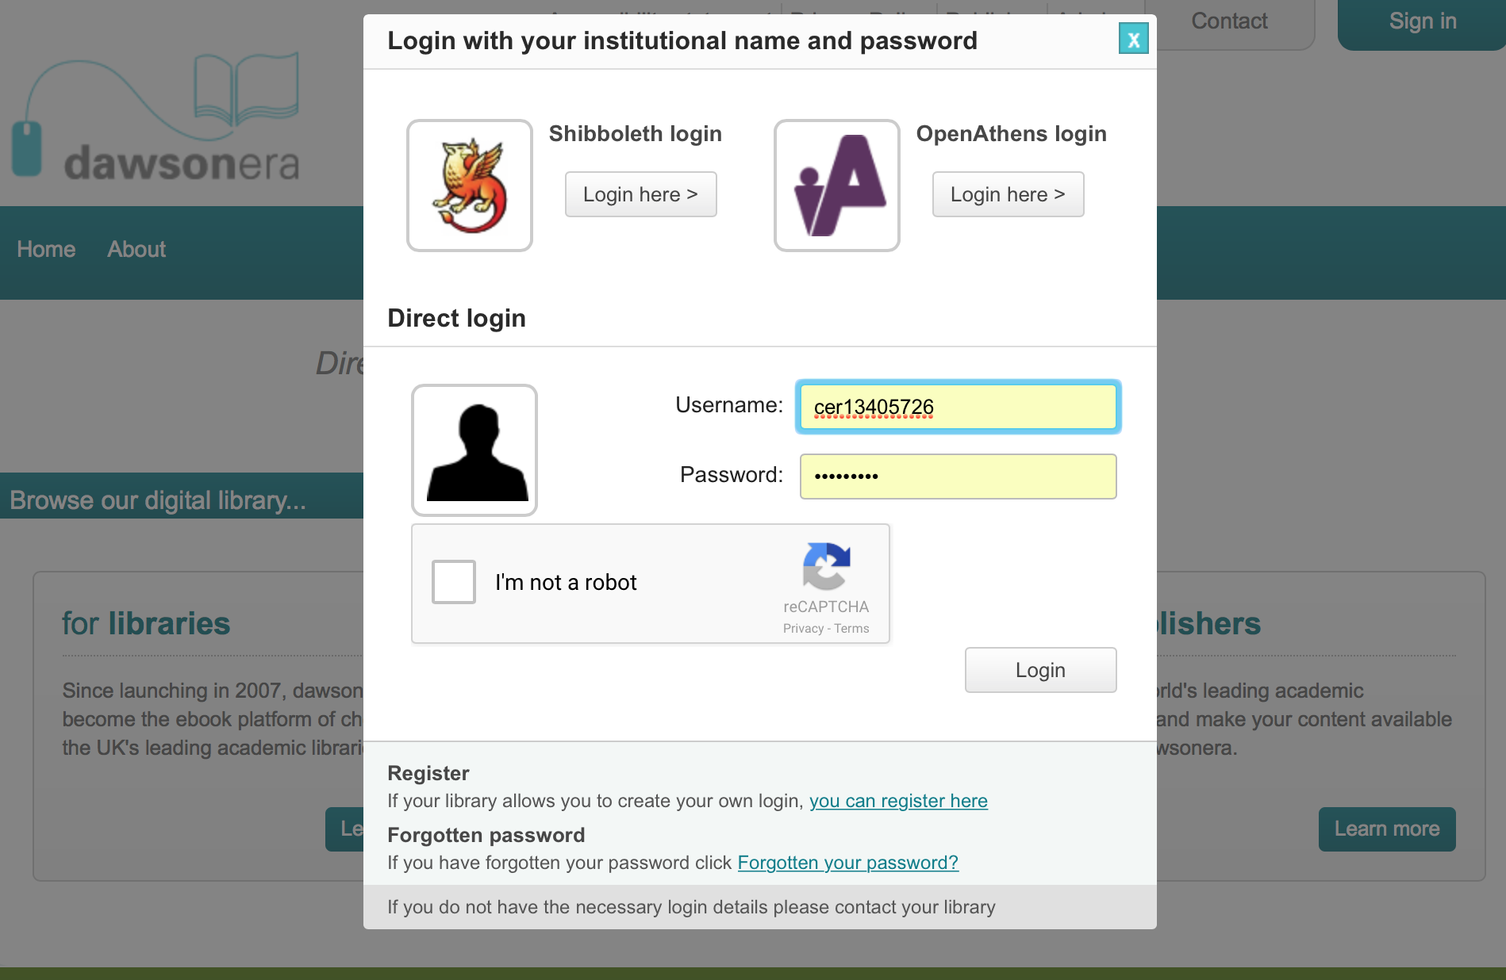

Then find university of the arts london

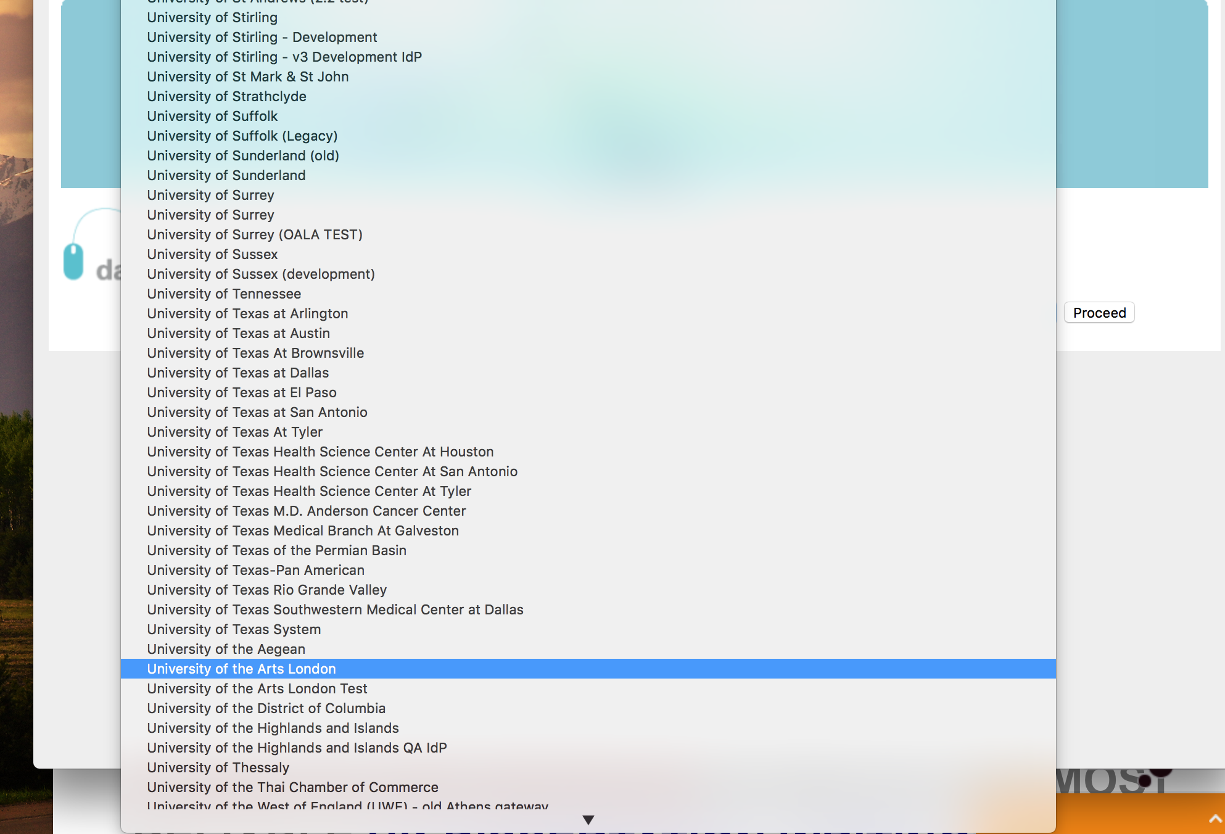

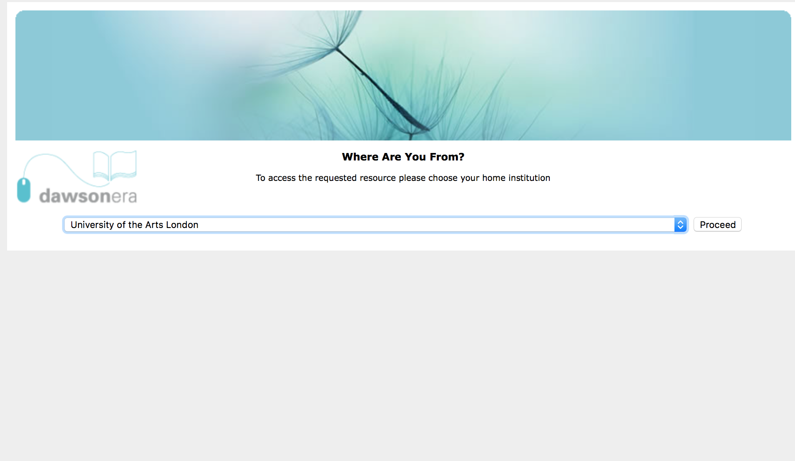

Log in as normal

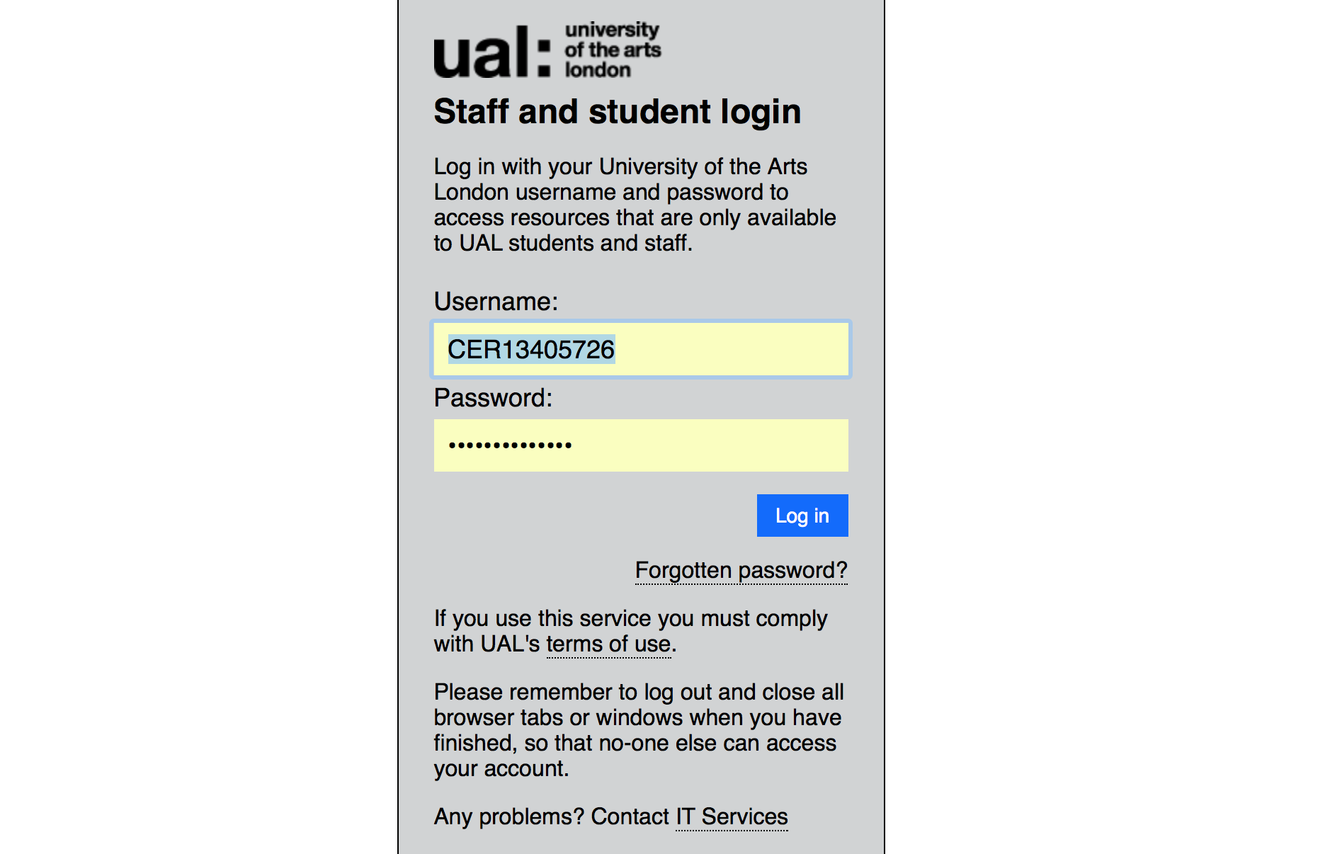

Methodology:

My supervisor suggested interpretive (explore opinions, views)
Inductive research.
Qualitative approach.
Industry interviews 6 or 7 from store managers and any required head office people.

Main focus – Burberry (I work for Burberry, so I will be able to help you with shaping interviews and adding names)
Tom Ford.
Interviews can be anonymous. All interviews must be scripted and added into appendixes.
I can guide you with answers needed as I do have knowledge about this as I am working in the industry. Just contact me anytime and we can come up with this together.

I think Prada and LV do limited see now buy now stuff. Please find more.

Use authors Bryman and Bell(!), can be Ballantine et al, Saunders at al etc

Use secondary research to find out what brands did what, sales etc…..

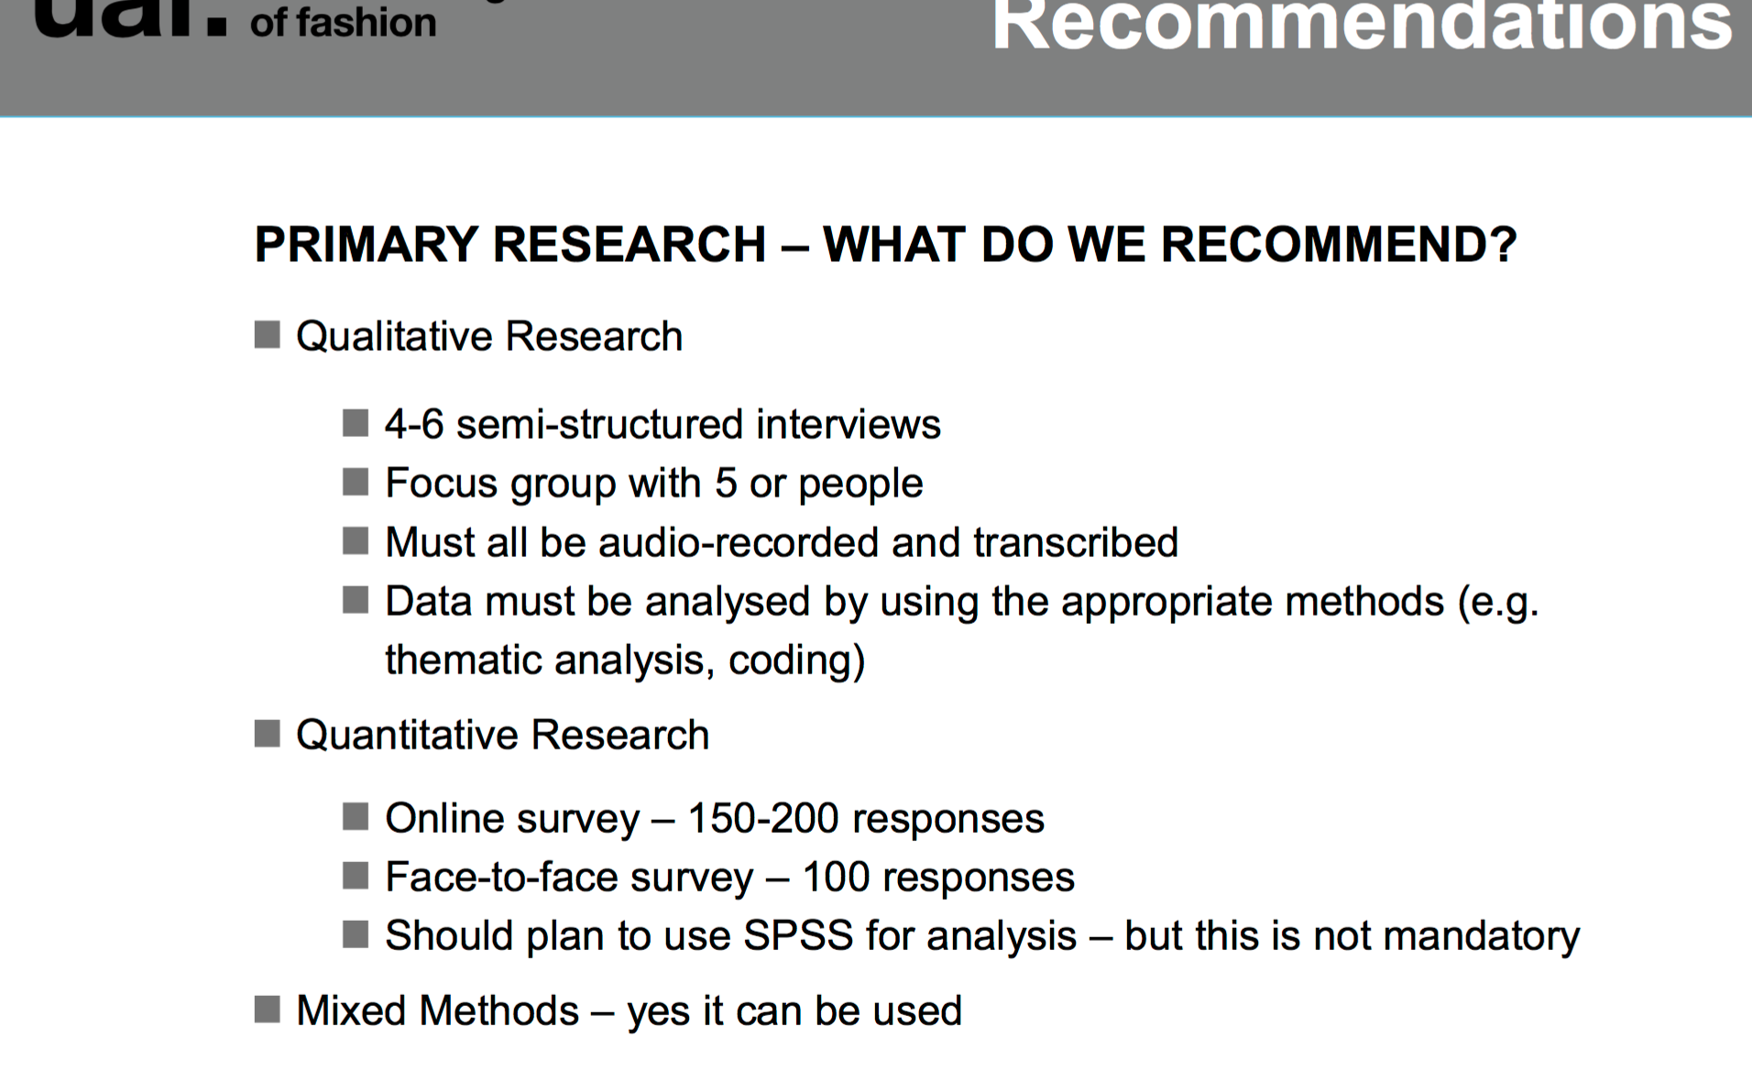

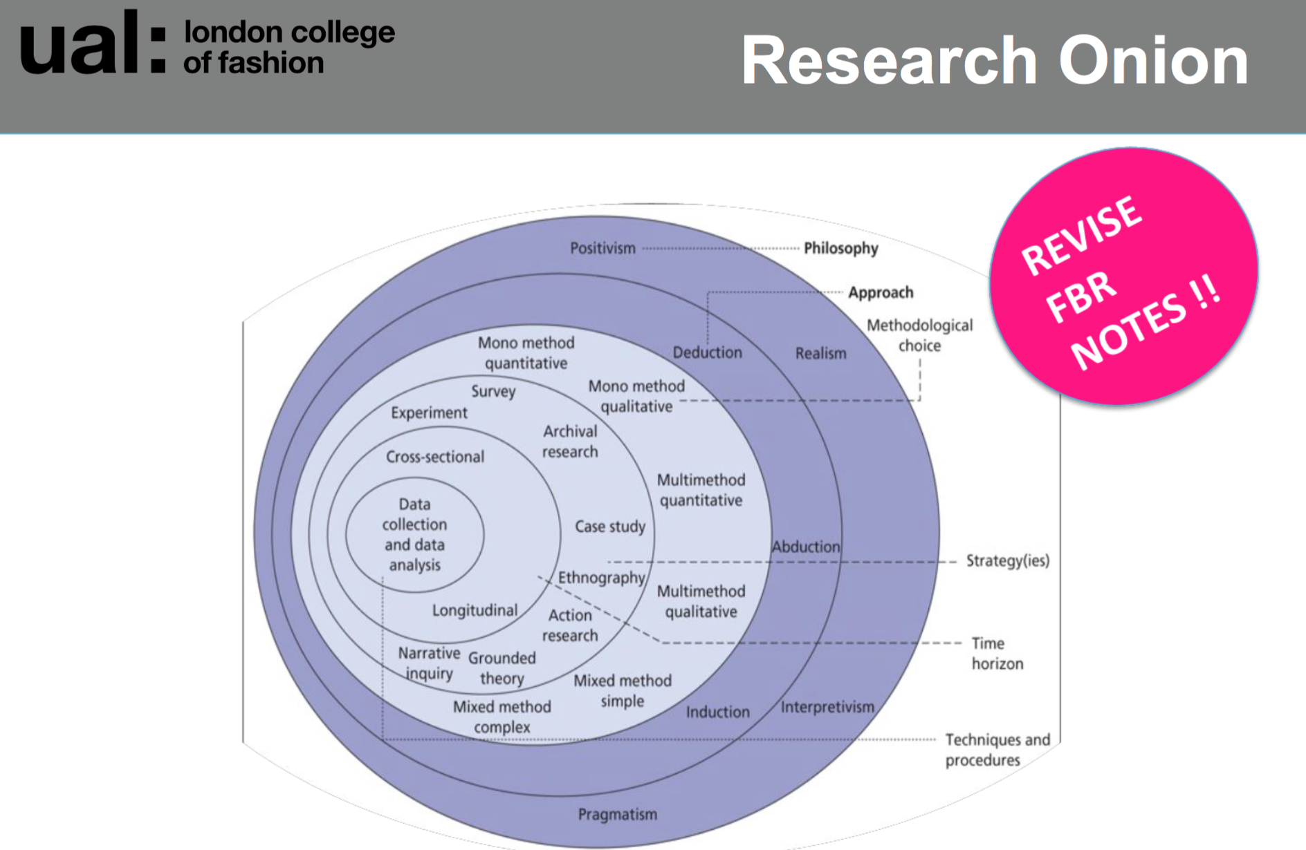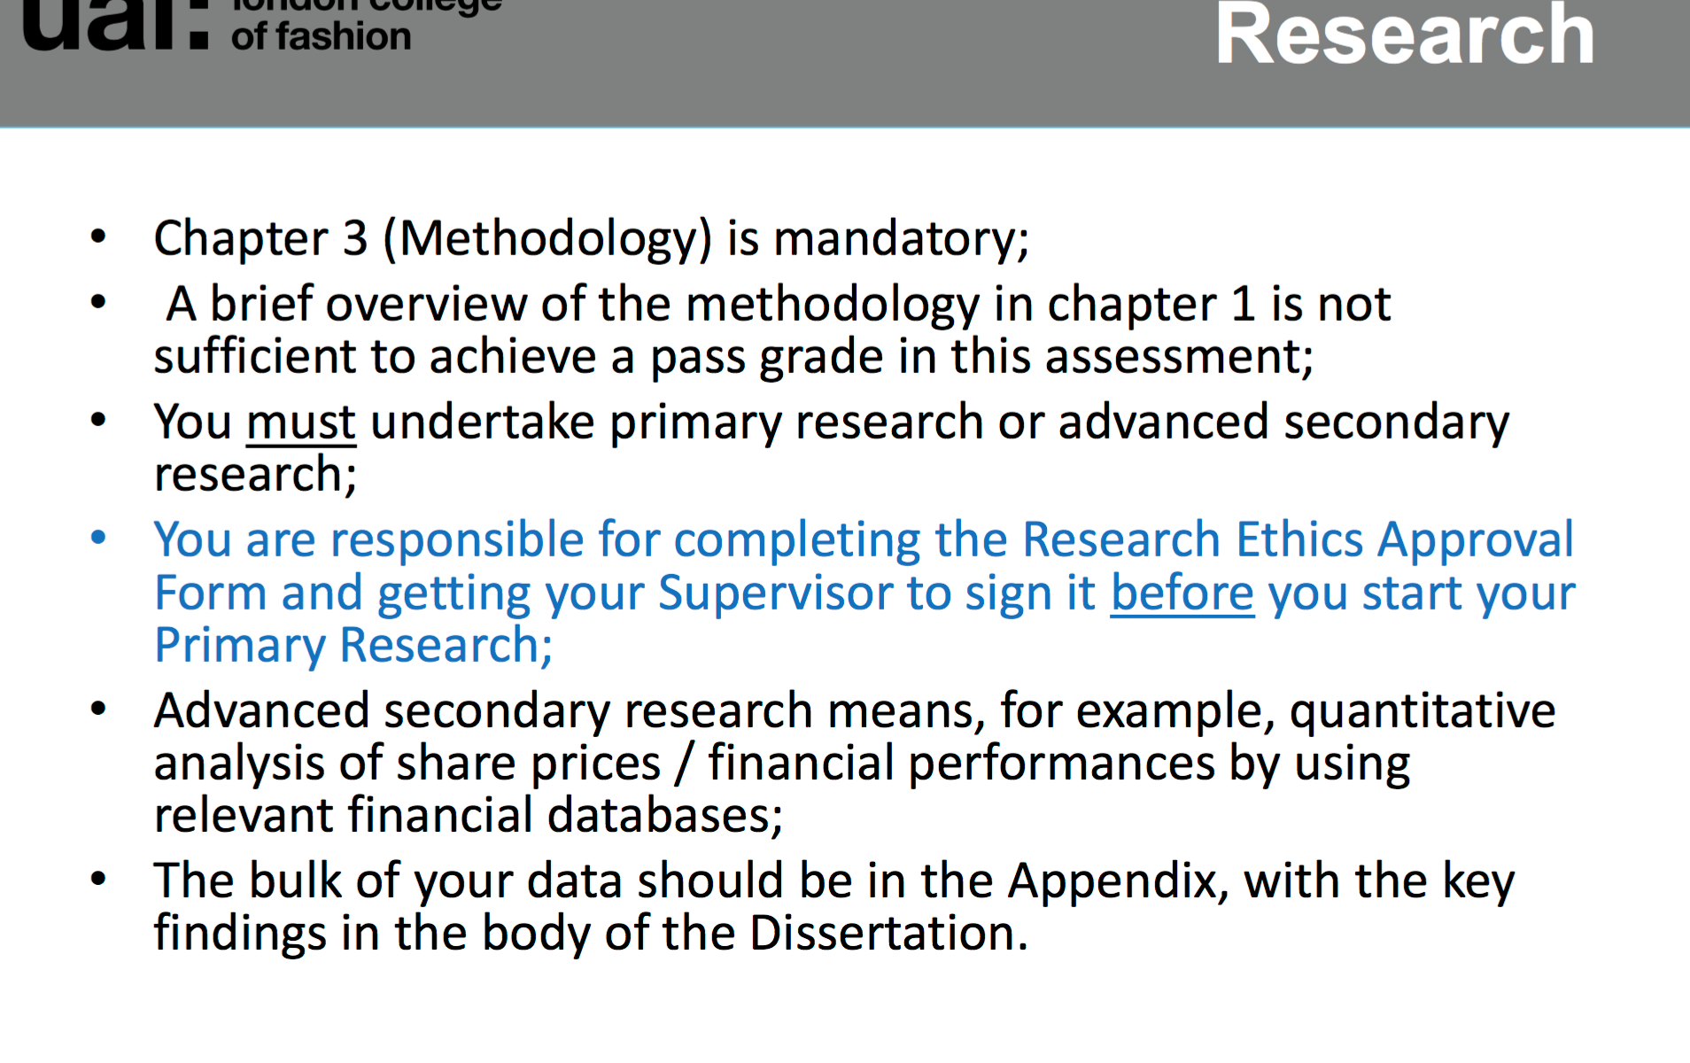

Outline limitations.

Then Findings presentation and analysis.

Discussion and Conclusion.

Good luck with the writing and please send me chapter by chapter along the way so I can read them and discuss needed changes or anything else with you. I hope it will not take very long to write it as I added as much guidance and information as I could. If you need anything else let me know anytime.
Thank you.
All the best.

D.

